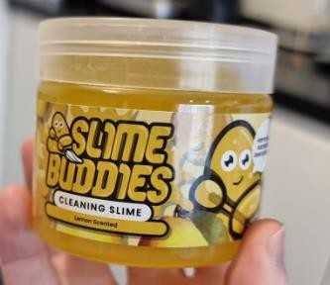
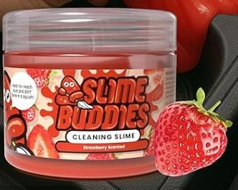
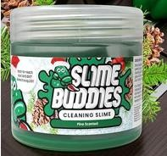
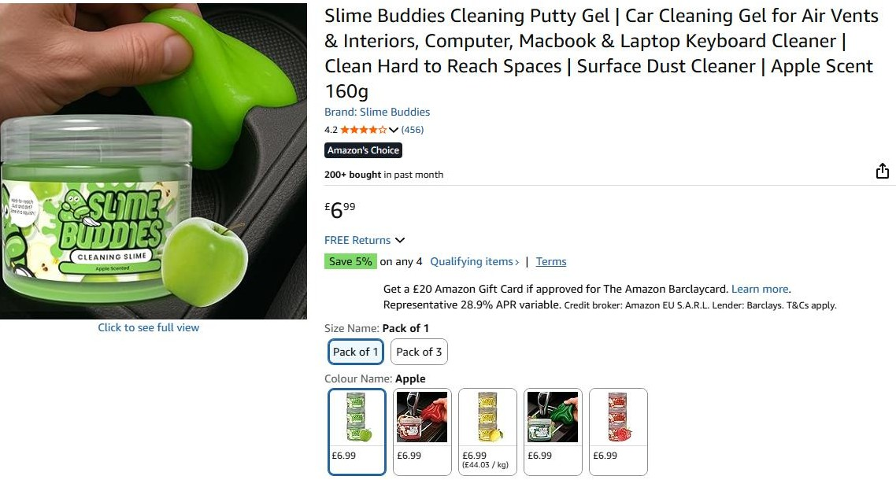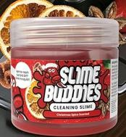

25,620pcs x Slime Buddies 160g Cleaning Putty Gel for Air Vents, Interiors, Computers etc………..Selling on amazon for £6.99
Breakdown;
Apple – 9,684pcs (EXPIRY JUNE 2026) Lemon – 2,881pcs (EXPIRY JUNE 2026) Strawberry – (EXPIRY 9,444pcs)
Christmas Spice – 1,776pcs (EXPIRY DEC 2026) Pine – 1,835pcs (EXPIRY DEC 2026)

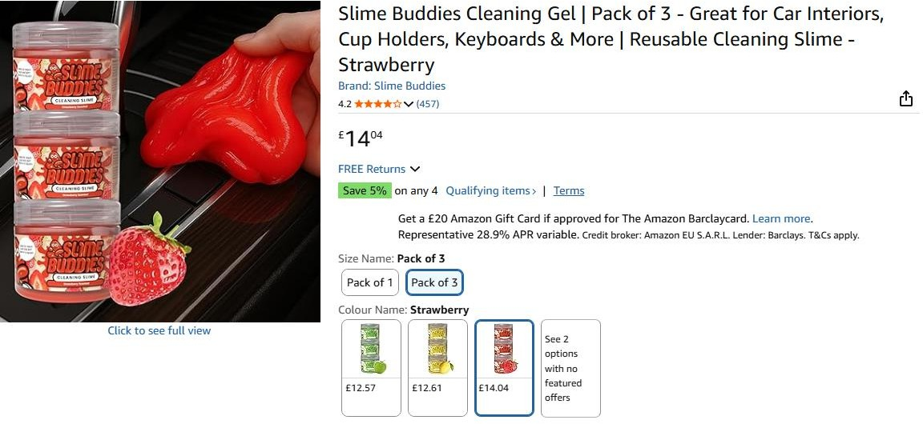
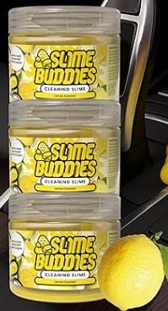

2,251 x 3 Pack Slime Buddies 160g Cleaning Putty Gel for Air Vents, Interiors, Computers etc Selling on amazon for £14.04……
Breakdown;
Strawberry – 1,295 Sets of 3pcs (EXPIRY JUN 2026) Lemon – 956 Sets of 3pcs (EXPIRY JUN 2026)

